Technical Datasheet for WIN-CN-1M-1TCP Modbus RS485 to Modbus TCP Converter:

Product Overview : -
The RTU to TCP Converter is a highly versatile and efficient device designed to convert Modbus RS485 data into Modbus TCP, enabling seamless integration with modern networked environments. Capable of hosting up to four masters simultaneously, this converter is an ideal solution for industrial
Applications where multiple devices need to communicate over a TCP/IP network.
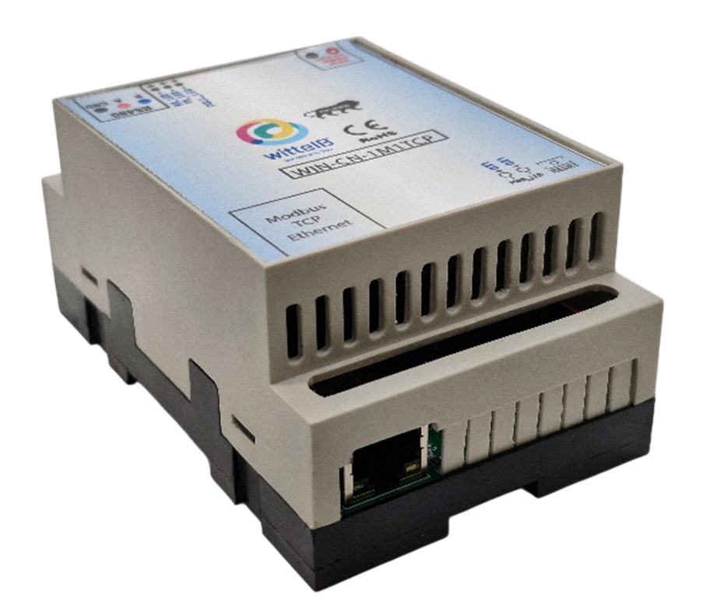

The IO modules are mounted on DIN rail mountable casing and with exposed connectors and LED indicators.

The design of the modules incorporates ‘resettable Fuses’ to safeguard against reverse polarity connection both for Power and Communication port.

Specifications
General –
Dimensions 70 mm L x 110 mm B x 50 mm //need to change
Power Input Power – 12 – 24 VDC or 24 V AC/DC
Typical – 12V DC @ 80mA
Operating Temperature 0 – 60° C (32 ~ 140°F)
Storage Temperature -20 - 70° C (-4 ~ 158°F)
Storage Humidity 5 ~ 95 % RH, non – Condensing
Certifications 

Key Feature:
- Modbus RS485 to TCP Conversion: Effortlessly converts Modbus RS485 data into Modbus TCP, allowing legacy serial devices to communicate over Ethernet networks.
- Support for Multiple Masters: Hosts up to four Modbus masters, making it suitable for complex systems requiring multiple control points.
- Web UI for Easy Configuration: A user-friendly web interface simplifies the configuration of RS485 settings and TCP/IP parameters. This intuitive interface ensures that users can quickly and easily set up the device without needing specialized technical knowledge.
- Web UI for Easy Configuration: One of the key advantages of this converter is its ability to display data locally through the web UI. This feature not only aids in the integration and installation process but also significantly enhances troubleshooting capabilities. Users can monitor data flow in real-time, making it easier to identify and resolve issues without additional tools or software.
- Seamless Integration: The device is designed for easy integration into existing systems, reducing the time and effort required to set up and maintain communication networks in industrial environments.
The RTU to TCP Converter is an essential tool for any operation that requires reliable, Easy to use, manage communication between Modbus RS485 devices and modern TCP/IP networks. Its ability to support multiple masters and offer local data viewing Makes it a standout choice for industrial applications, ensure efficient and streamlined operation.

Application: -
- Industrial automation systems.
- Building management systems.
- Energy monitoring and management.
- Remote monitoring and control systems.
- Process control systems.

Additional Features: -
Communication port isolated
Input power reverse polarity safety
ESD Safety IEC 61000-4-2, ± 30KV contact, ± 30KV air
EFT IEC 61000-4-4, 50A (5/50ms)
750V isolation.
CRC Error check.
No configuration needed on the IO board

Configuration Step: -

- Connect 24 V AC/DC Supply to the Module.
- Connect MODBUS RTU Multiple Slave devices or Single devices to the A & B Terminal of Module.
- Connect MODBUS TCP Network Ethernet Cable to the Ethernet port of the
module.
- Default IP Address of Module for RTU-TCP connection is “192.168.1.254”and
Port “502”.
- After connecting we are ready to simulate the RTU to TCP Conversion.
- For Configuration or to view data locally, we need to connect to the Module's AP (Access Point) mode over Wi-Fi at “192.168.4.254”.



- The default AP SSID (name) is WIN_RTU-TCP_XXXXXX
- The default password is: wittelb2024 Note: XXXXX is a unique number referring
to portion of MAC ID.
- After connecting to the AP mode over Wi-Fi, please enter “192.168.4.254”
- on your browser, and make sure your system/PC should be in the same network
- as of the Module’s Access Point.
- After entering above IP Address, you will find a webpage which has 3 Pages for Configurations.
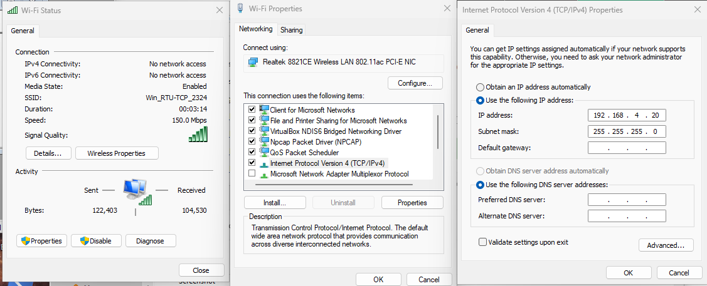
- The first page is set up for custom user IP address settings of the RTU-TCP Convertor.

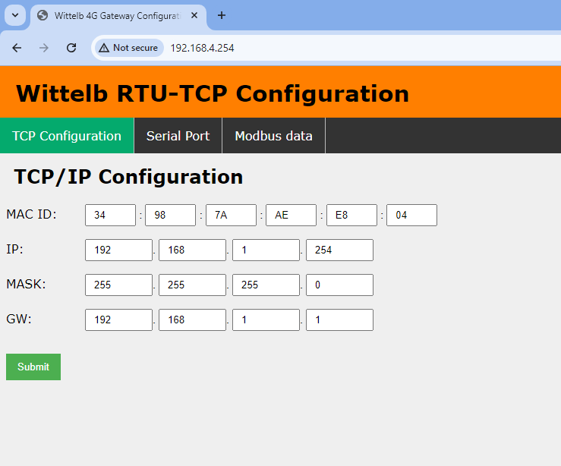
- Users can input custom Mac ID, IP, Gateway and Subnet Mask and press submit to save the TCP Configurations for RTU-TCP conversion.
- Serial port RS485 Settings and Local Modbus Data can be viewed by clicking on the top Selection Panel.
- On second page RS485 configuration can applied by user.
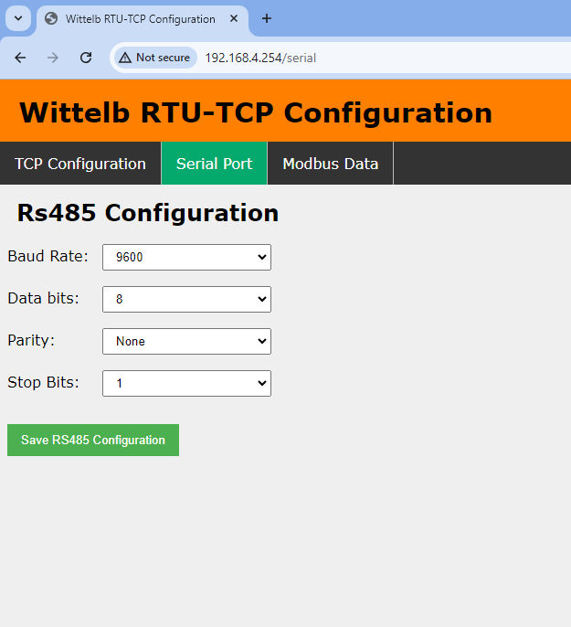
- Baud rate selections, Data Bits, Parity, Stops Bits can be configured on this page
- Third page is for polling and viewing Modbus RTU data locally.
- It gives user access to the device connected over Modbus RTU.
- User can enter the:

Slave ID- the ID of connected Modbus RTU device.

Start Address- the address of the register from where we want to read data from.

Quantity- Number of the register that we want to read/ get data.

Function Code- the corresponding function code of the slave.

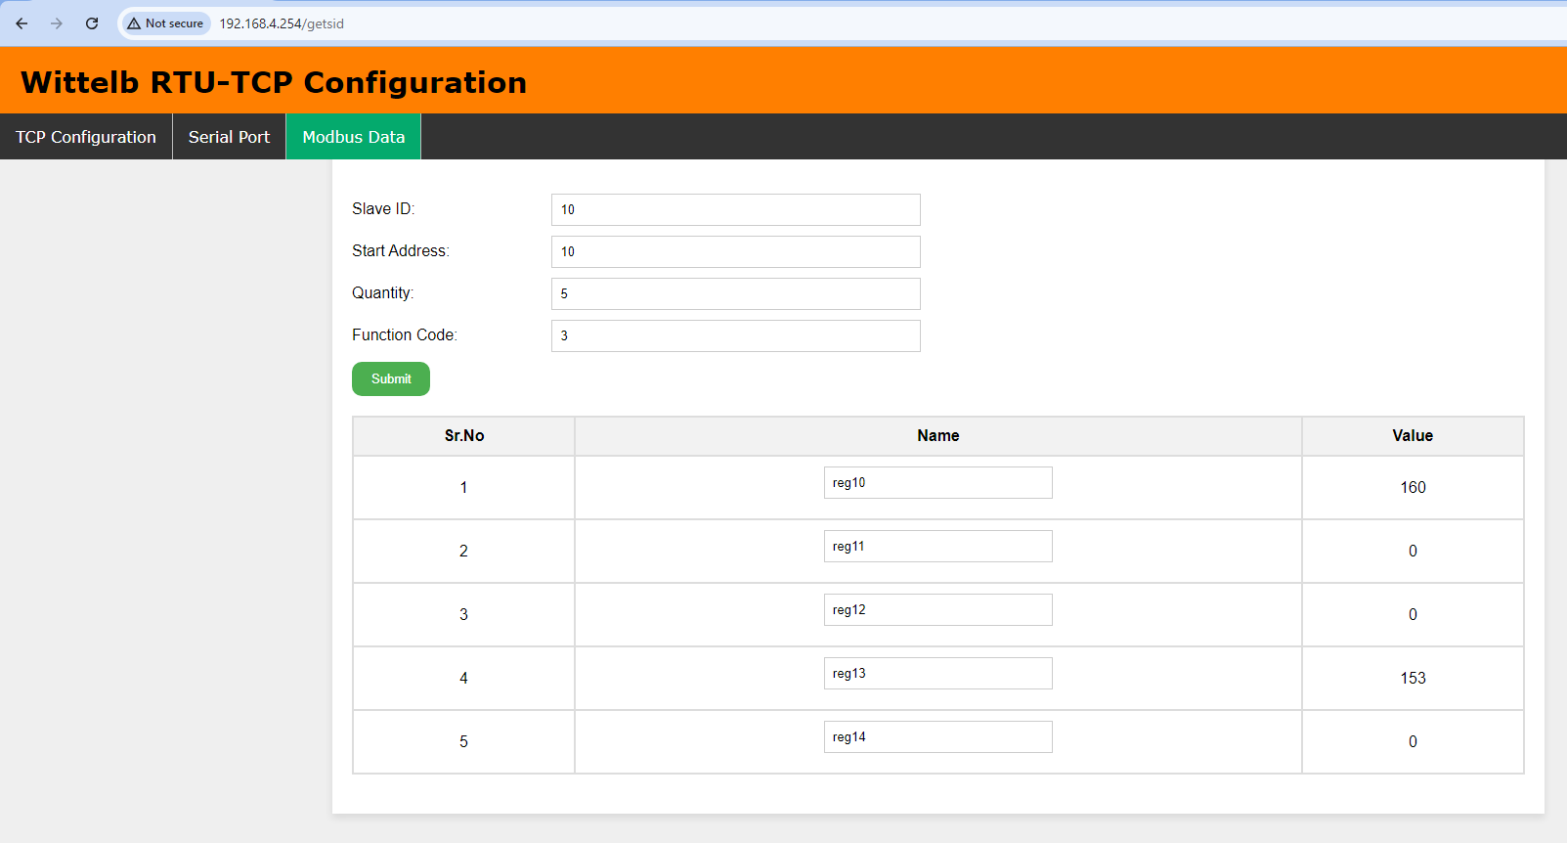

- And click on submit to fetch the data represented along with the register number
and its value on a tabular form.

- Note – This feature is of great help for the customer to review the Modbus data
post its connection with the module and can also help in identifying faults in case
of data loss at the TCP side etc.
Recommended Cable Electrical Characteristics: -
22 AWG Cable Shielded and twisted pair should be used.
Tinned Copper Recommended
Nominal Conductor DCR 14.7 ohm / 1000 ft
Nominal Capacitance 11 pf / feet (conductor to conductor)
High Frequency Non-Insertion Loss 0.5db / 100ft

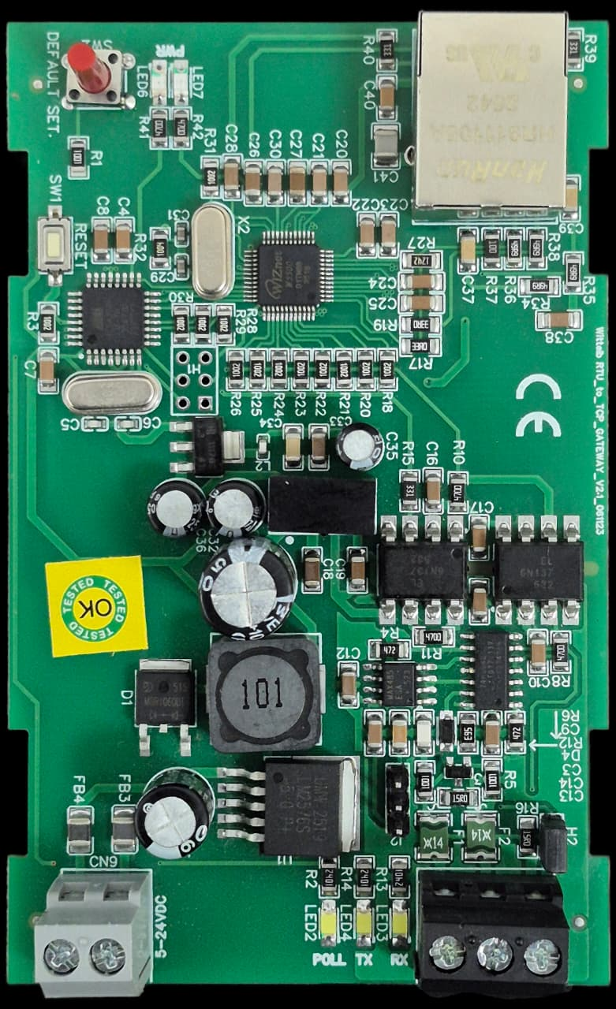
Modbus
RS 485
5-24V DC
INPUT
ETHERNET PORT
POOLING LED
POWER LED
DS RESET

Contact us: -
Augmatic Technologies Pvt. Ltd.,
Plot no 6, Shah Industrial Estate II,
Kotambi,
Vadodara – 391510.
Email – Sales@wittelb.com
Support: support@wittelb.raiseaticket.com / +91 94038 92805

